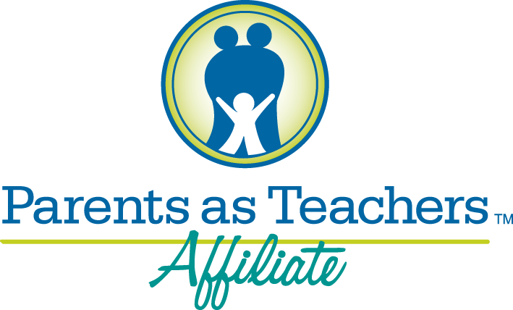

Your Child’s First Teacher is YOU!!

What is Parents as Teachers?
Parents as Teachers is a home visiting program that helps young children become better learners well before they get to school. We help parents and family members link to other community resources and learn from other families and become more involved in their child’s development.

What do you receive from Parents as Teachers?
- Regularly scheduled home visits from a trained Parent Educator who brings parenting and child development/behavior tips based on your child’s age
- Age- appropriate activities you can do with your child to encourage learning
- Free health and developmental screenings
- Prenatal support, postpartum support, and infant care education

DATE: Referral Source:
Family Name:
Address:

Phone:

Are You Pregnant YES NO If yes, what is your due date:
Do you have a child under 24 months of age? YES NO If yes, Birthdate:
Comments:

I hereby authorize the above mentioned provider to release my name to Parents as Teachers who may contact me with information about their services.
_______________________________________________________________________________________
Family Signature Date

Please email this form to PAT@wycrp.org Call 307-632-0032 for more information
